Basic logic program

1.Display This Information using printf

a. Your Name

b. Your Birth date

c. Your Age

d. Your Address

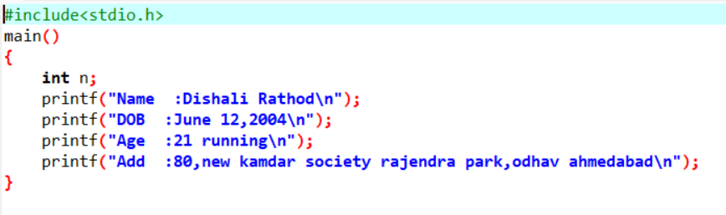

2. Write a program to make Simple calculator (to make addition, subtraction, multiplication, division and modulo)

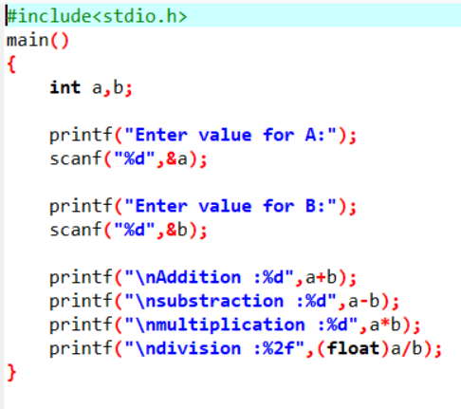

3. WAP to Find Area And Circumference of Circle

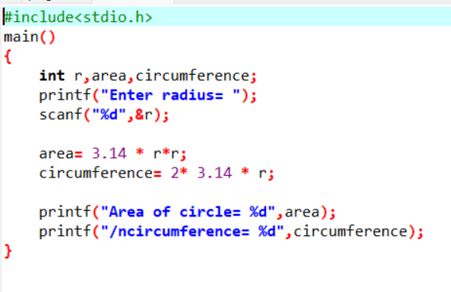

4. Find Area of Square formula : a = a2

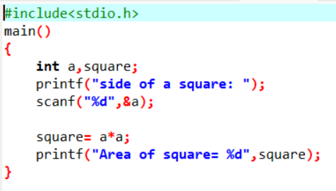

5. Find Area of Cube formula : a = 6a2

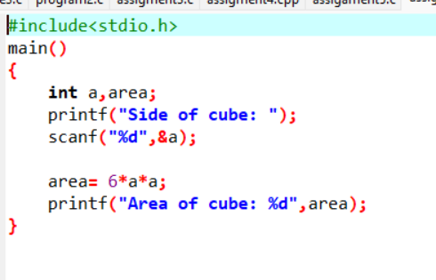

6. Find area of Triangle Formula : A = 1/2 × b × h

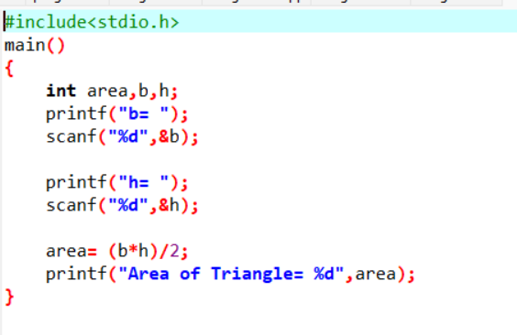

7. Find area of Rectangle Formula : A=wl

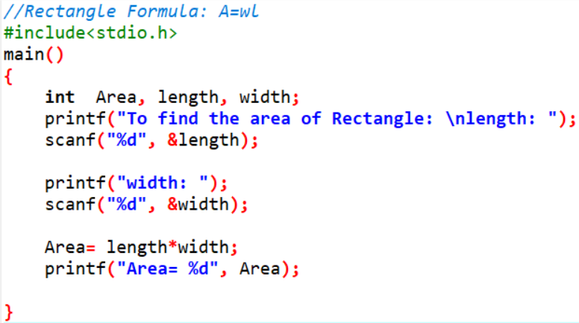

8. Find circumference of Rectangle formula : C = 4 * a

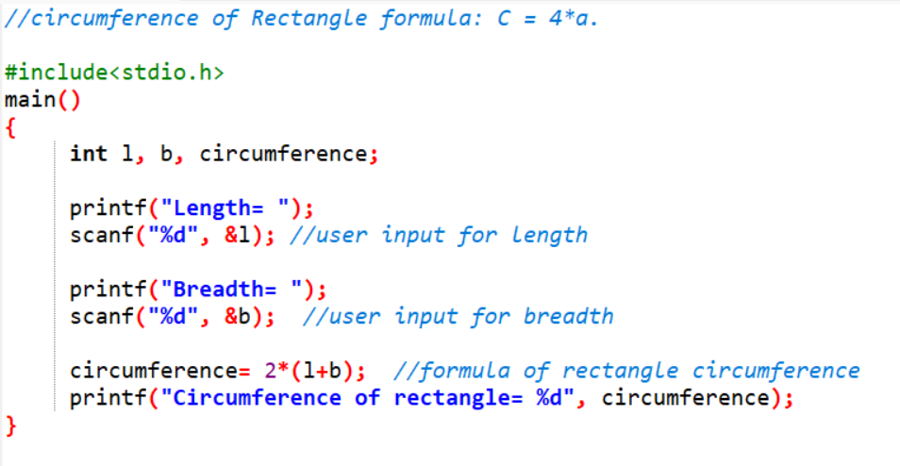

9. Find circumference of Triangle formula : triangle = a + b + c

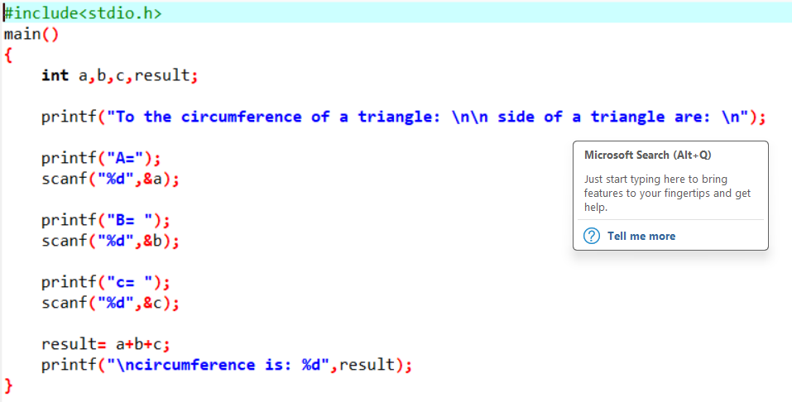

10.find the area of a rectangular prism formula : A=2(wl+hl+hw)

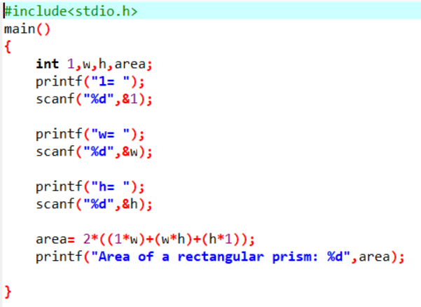

11.Find circumference of square formula : C = 4 * a

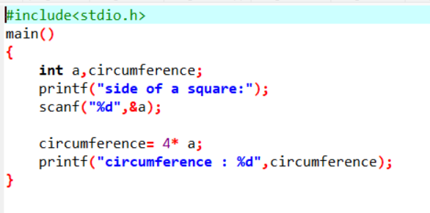

12.Accept number of students from user. I need to give 5 apples to each student. How many apples are required?

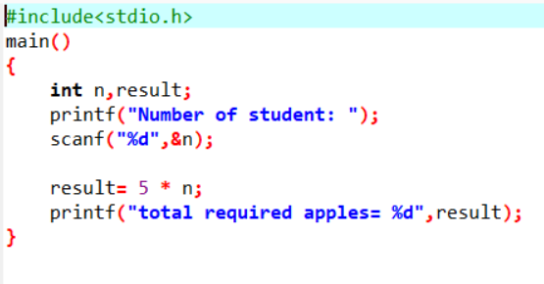

13.Find character value from ascii

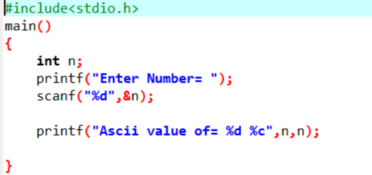

14.Find ascii value of given number

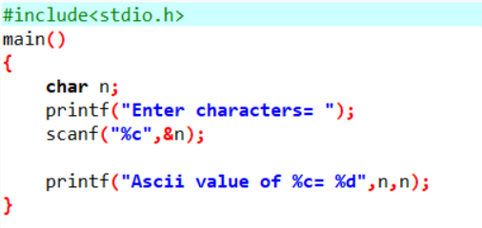

15.Convert school’s name in abbreviated form

16.Convert country’s name in abbreviate form

17.Calculate person’s insurance premium based on salary 18.Calculate person’s Annual salary 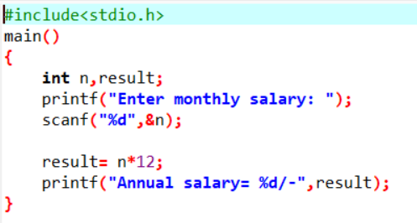

19.Calculate compound interest

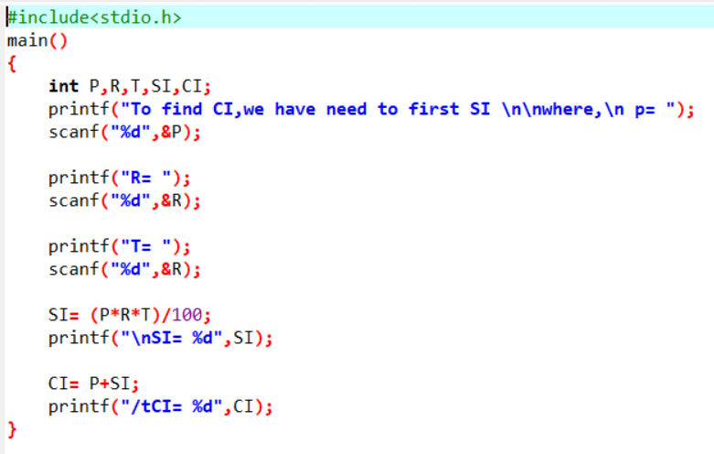

20.Accept monthly salary from the user and deduct 10% insurance premium, 10% loan installment find out of remaining salary.

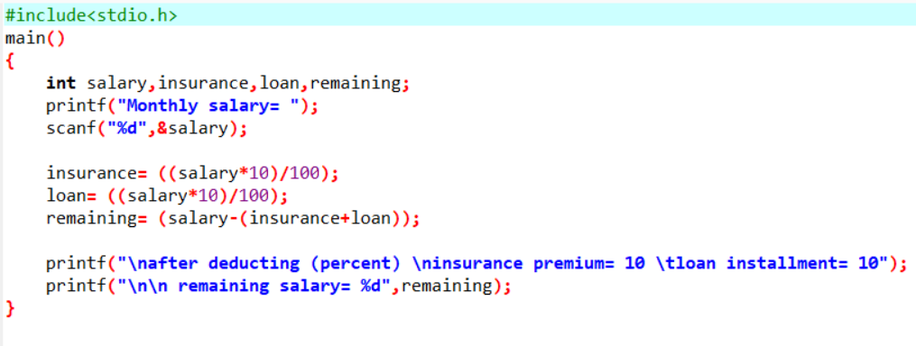

21.Accept 2 numbers from user and swap 2 numbers with using 3rd variable and without using 3rd variable

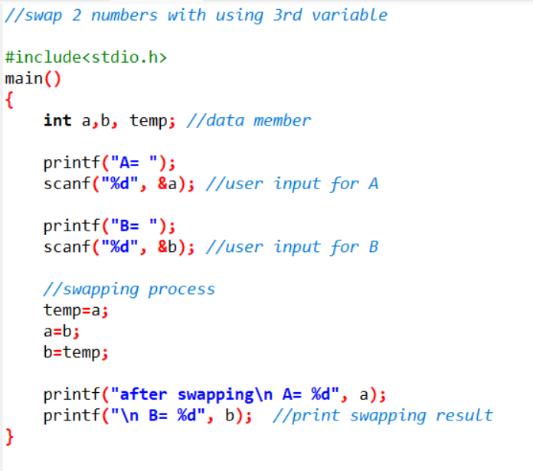

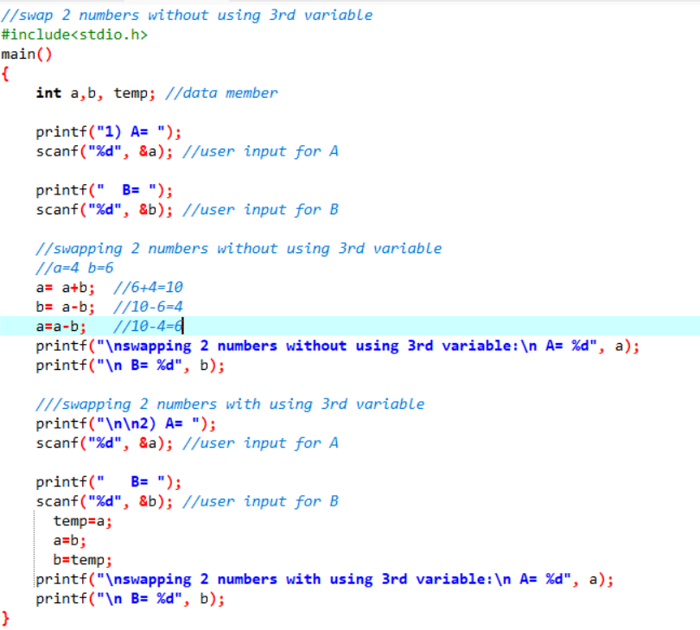

22.Calculate compound interest (Compound Interest formula: a. Formula to calculate compound interest annually is given by: Amount= P(1 + R/100)t b. Compound Interest = Amount – P

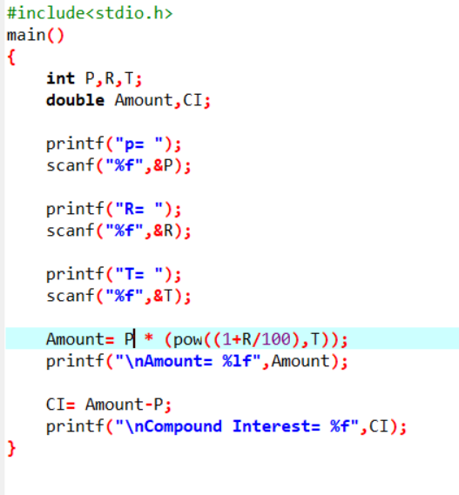

23.WAP to calculate swap 2 numbers with using of multiplication and division.

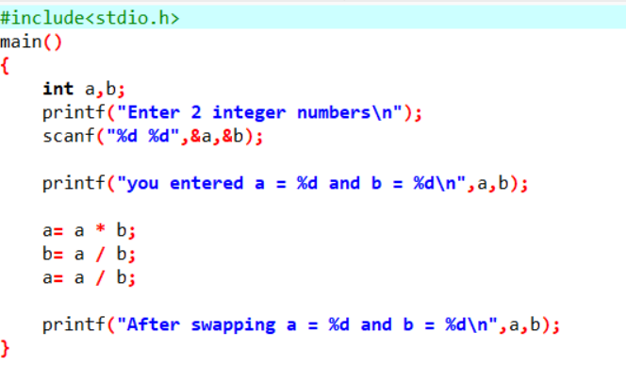

24.Accept 5 employees name and salary and count average and total salary

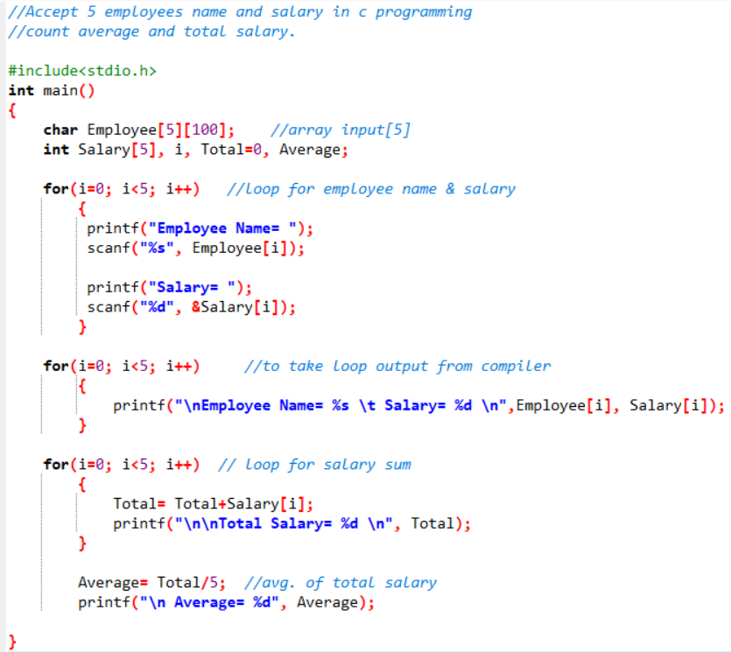

25.Accept 5 expense from user and find average of expense

26.Convert temperature Fahrenheit to Celsius

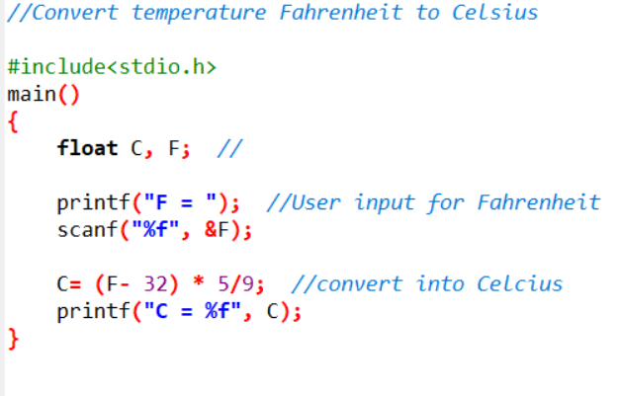

27.Convert days into months

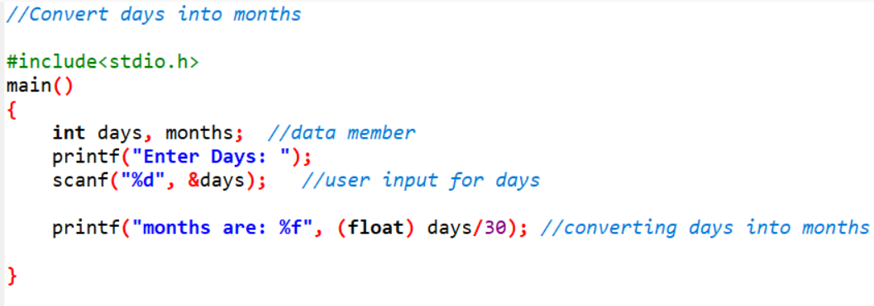

28.Convert years into days and months

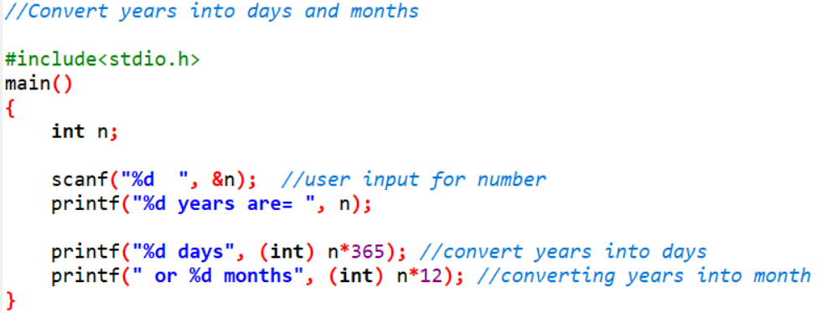

29.Convert minutes into seconds and hours

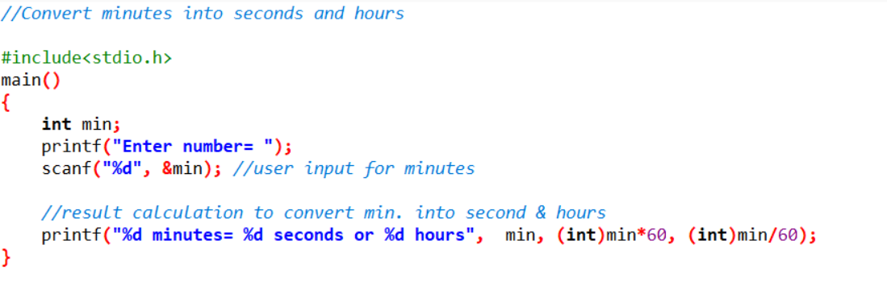

30.WAP to convert years into days and days into years

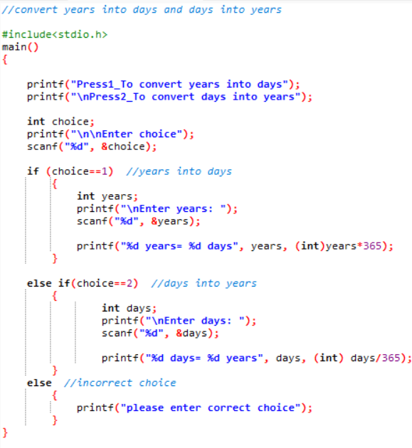

31.Convert kilometers into meters

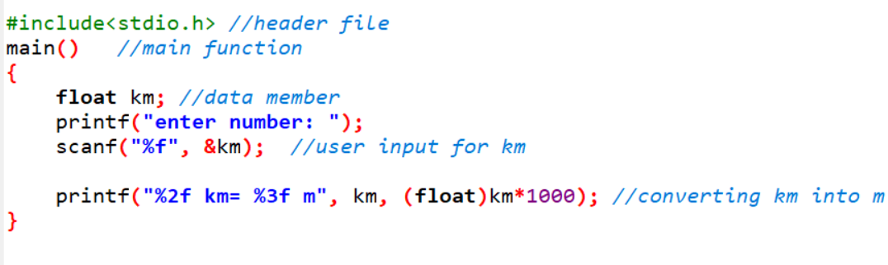

32.Accept 2 numbers and find out its sum check it size

33.C Program to Read Integer and Print First Three Powers (N^1, N^2, N^3)

Conditional Logic Programs:

1. Write a C program to accept two integers and check whether they are equal or not

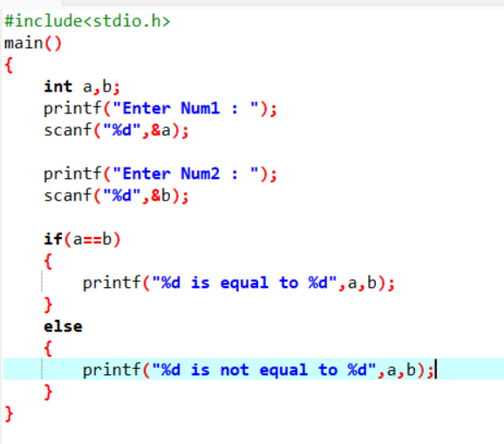

1. Write a C program to read the value of an integer m and display the value of n is 1 when m is larger than 0, 0 when m is 0 and -1 when m is less than 0

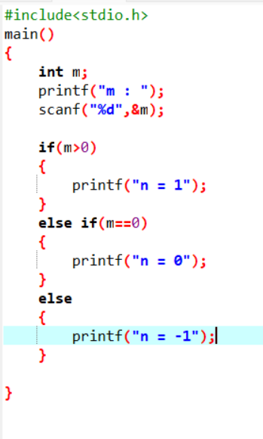

1. WAP to check if the given year is a leap year or not.

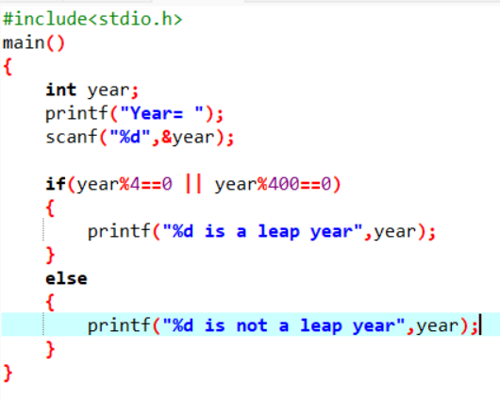

1. WAP to make simple calculator (operation include Addition, Subtraction, Multiplication, Division, modulo) using conditional statement

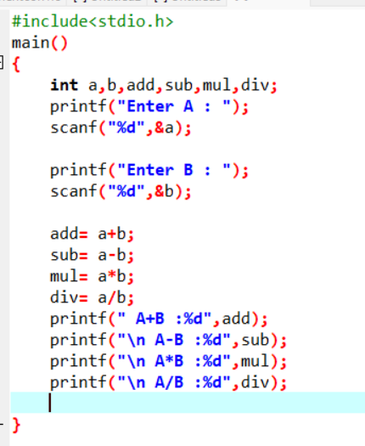

1. Check Number Is Positive or Negative

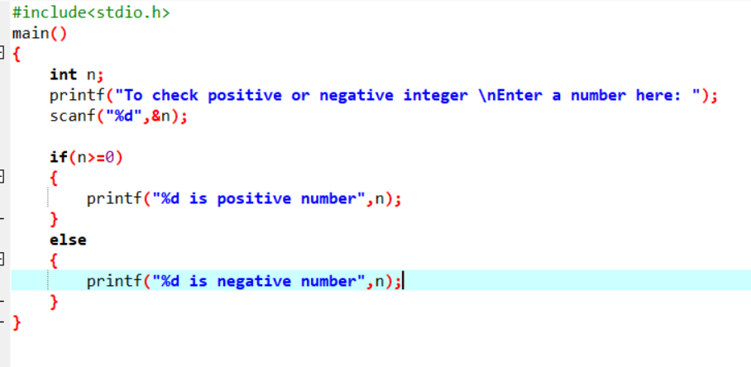

1. Find the Character Is Vowel or Not 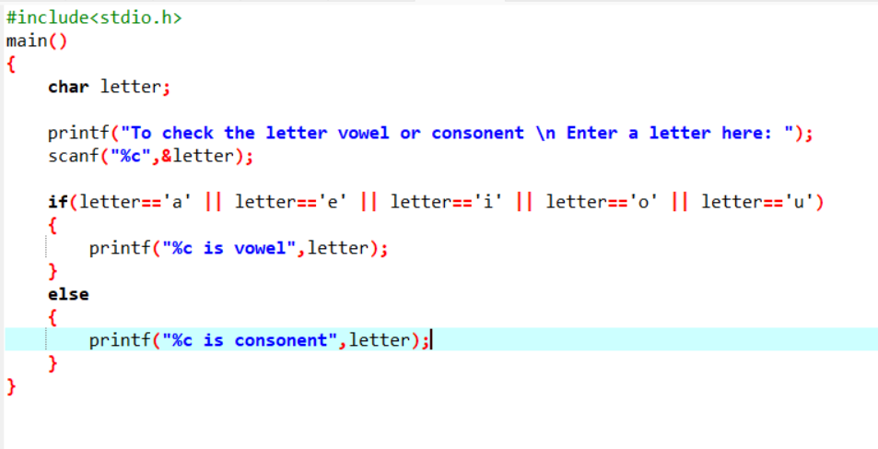
2. Accept marks from user and check pass or fail

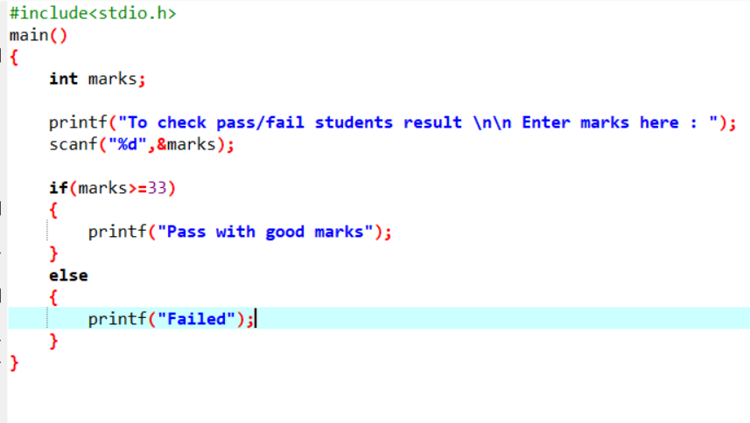

1. WAP to accept the height of a person in centimeters and categorize the person according to their height.

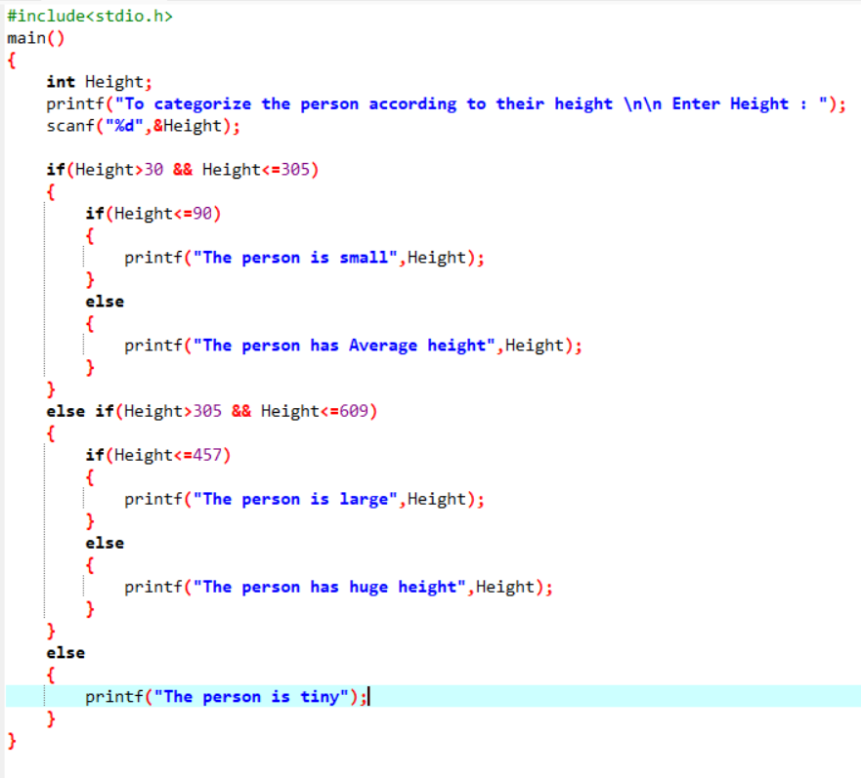

1. C Program to Check Uppercase or Lowercase or Digit or Special Character

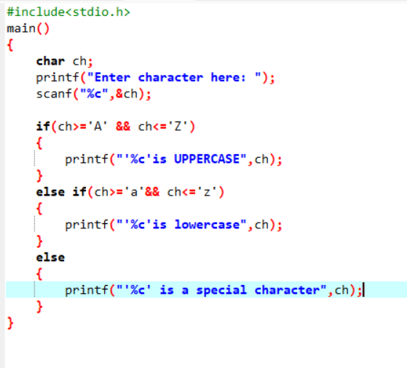

10.WAP to check whether a number is negative, positive or zero.

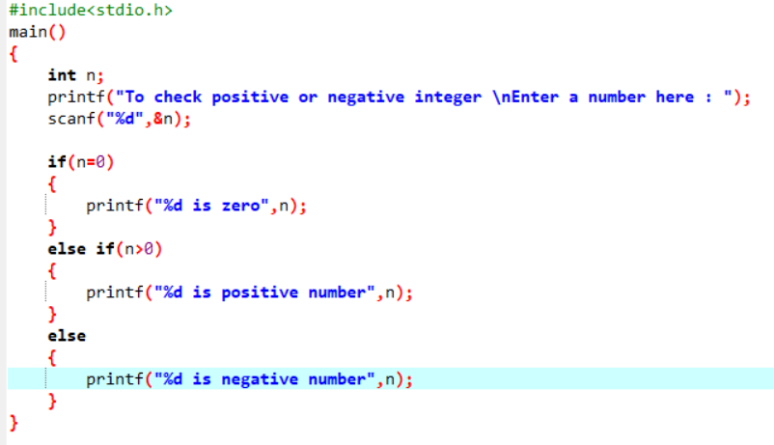

11.WAP to find number is even or odd using ternary operator

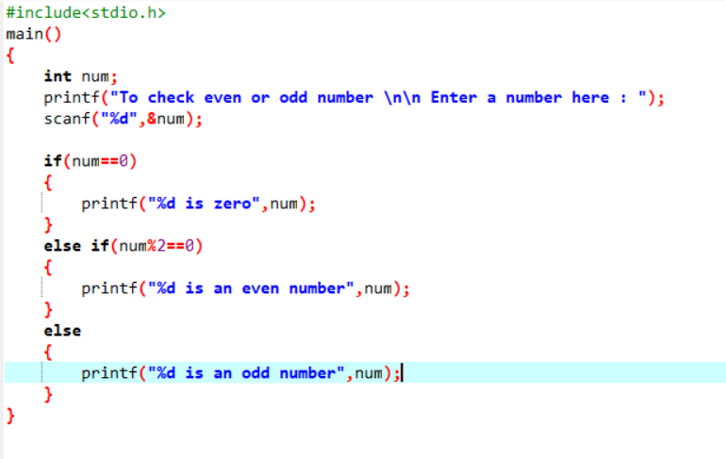

12.WAP to find maximum number among 3 numbers using ternary operator

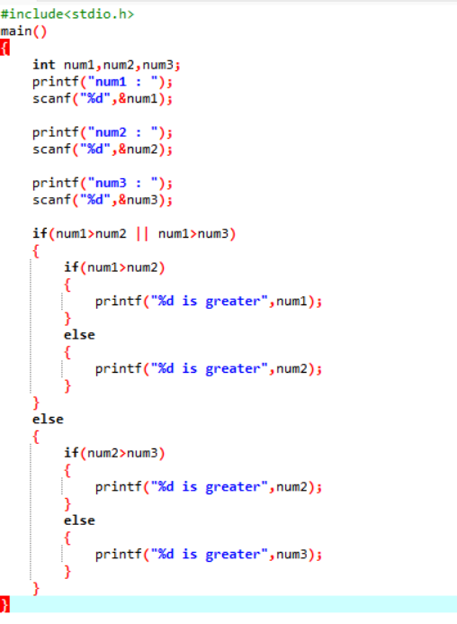

13.WAP to find minimum number among 3 numbers using ternary operator

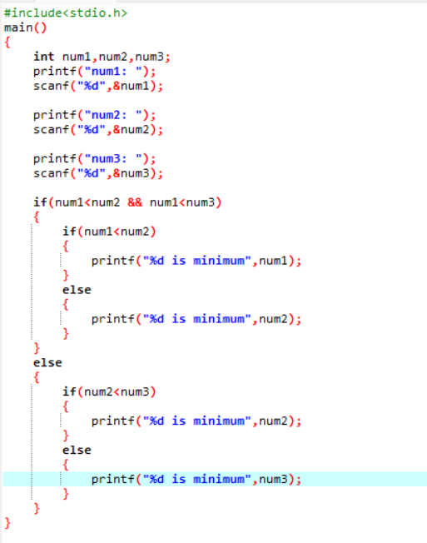

14.WAP to find the largest of three numbers.



15.Write a C program to determine eligibility for admission to a professional course based on the following criteria Eligibility Criteria : Marks in Maths >=65 and Marks in Phy >=55 and Marks in Chem>=50 and Total in all three subject >=190 or Total in Maths and Physics >=140 --------------------------------------Input the marks obtained in Physics :65 Input the marks obtained in Chemistry :51 Input the marks obtained in Mathematics :72 Total marks of Maths, Physics and Chemistry : 188 Total marks of Maths and Physics : 137 The candidate is not eligible.

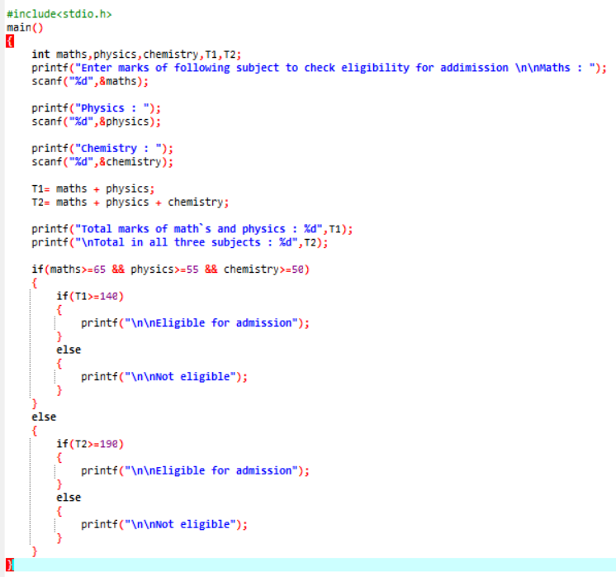

16.Write a C program to read temperature in centigrade and display a suitable message according to the temperature state below: Temp < 0 then Freezing weather Temp 0-10 then Very Cold weather Temp 10-20 then Cold weather Temp 20-

30 then Normal in Temp Temp 30-40 then Its Hot Temp >=40 then Its Very Hot

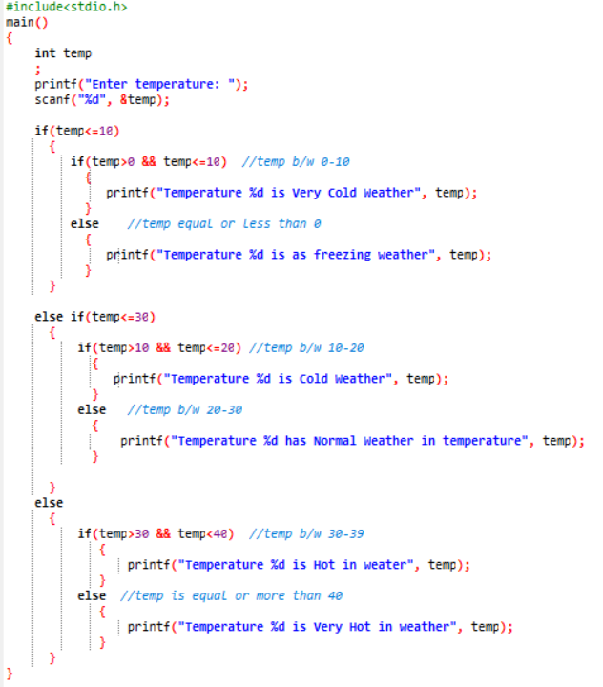

17.Write a C program to check whether a triangle can be formed with the given values for the angles.

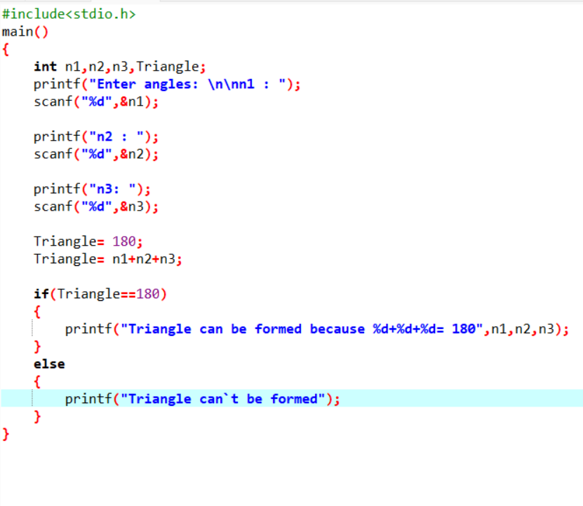

18.Write a C program to calculate profit and loss on a transaction

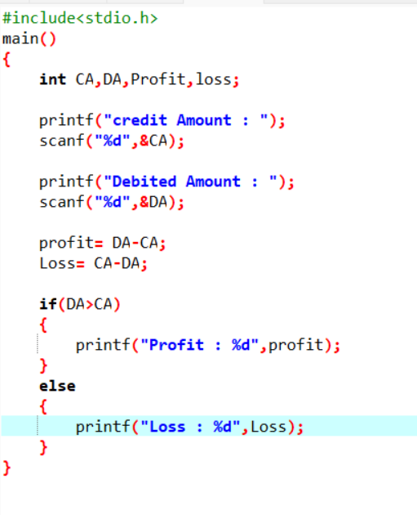

19.Write a program in C to calculate and print the electricity bill of a given customer. The customer ID, name, and unit consumed by the user should be captured from the keyboard to display the total amount to be paid to the customer. The charge are as follow :

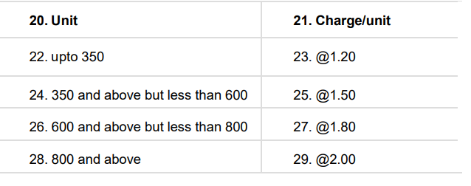

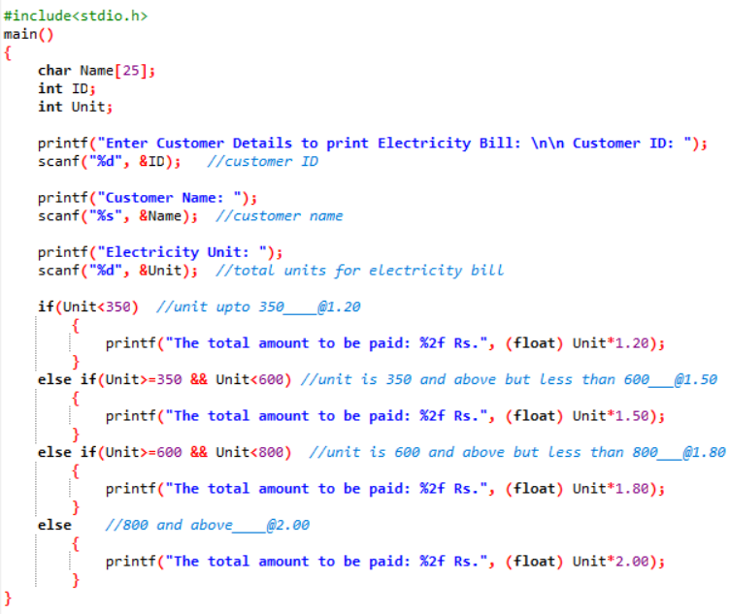

30.If bill exceeds Rs. 800 then a surcharge of 18% will be charged andthe minimum bill should be of Rs. 256/-

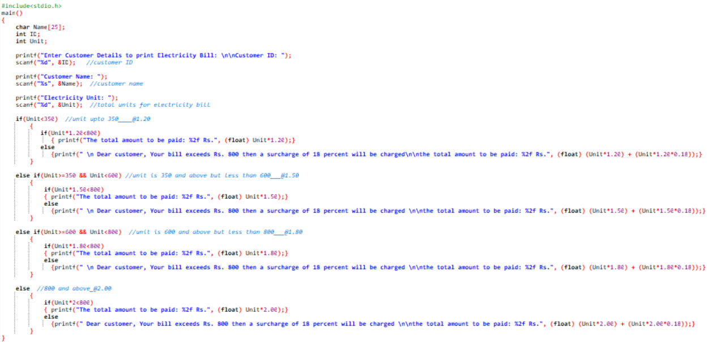

31. Write a program in C to read any Month Number in integer and display the number of days for this month.

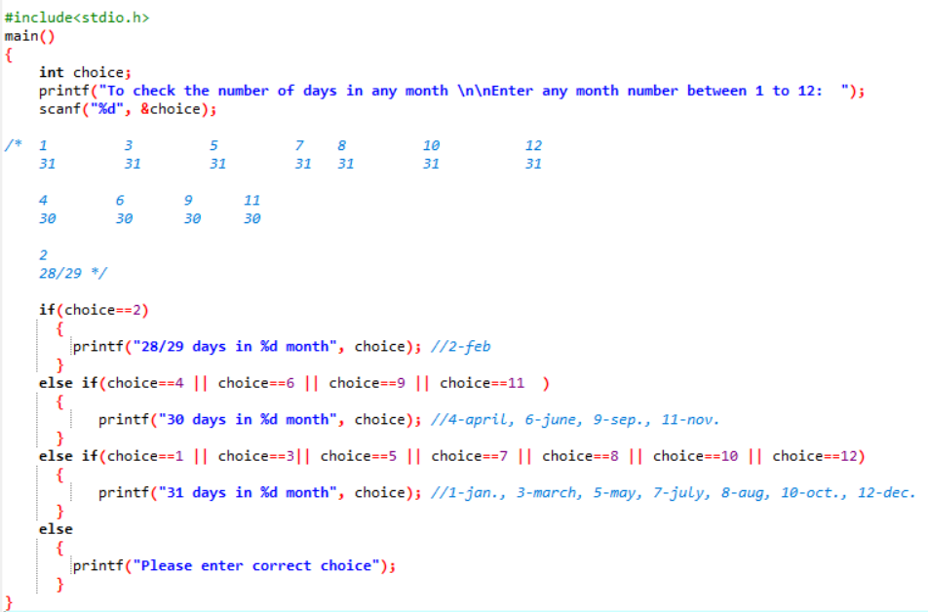

32.Write a C program to input basic salary of an employee and calculateits Gross salary according to following: Basic Salary <= 10000 : HRA = 20%, DA = 80% Basic Salary <= 20000 : HRA = 25%, DA = 90% Basic Salary > 20000 : HRA = 30%, DA = 95%\

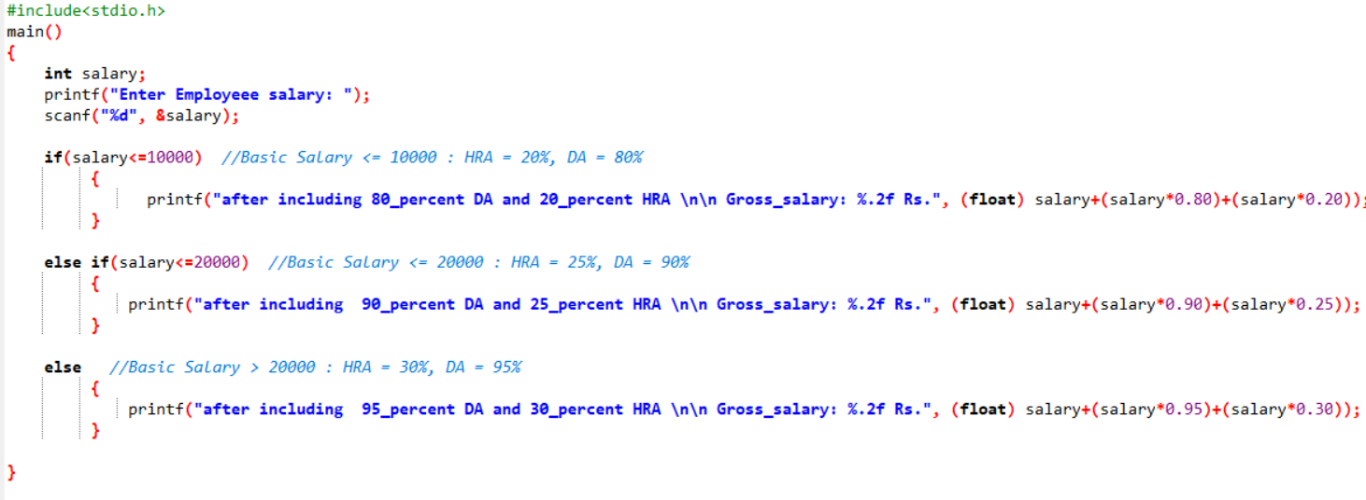

33. WAP to input the week number and print week day.

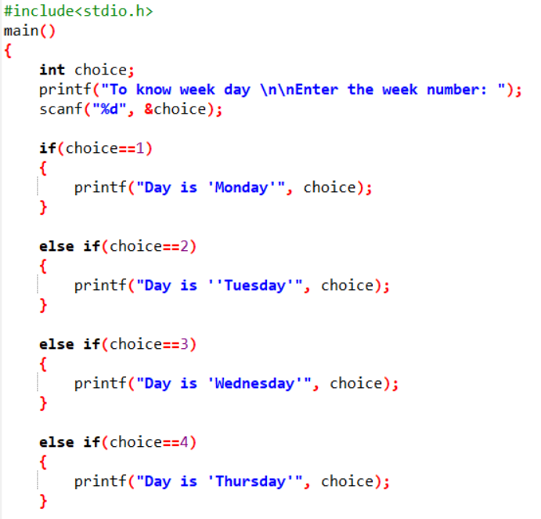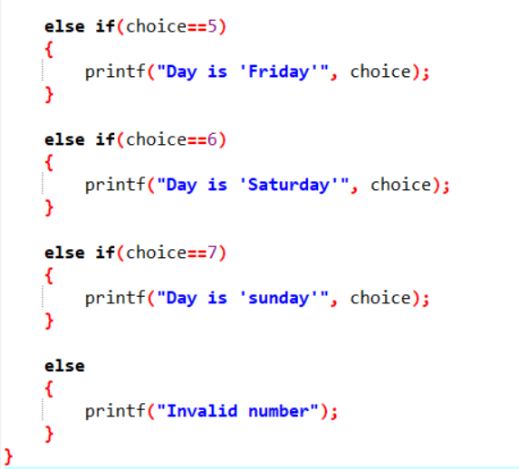

34. Accept month number and display month name

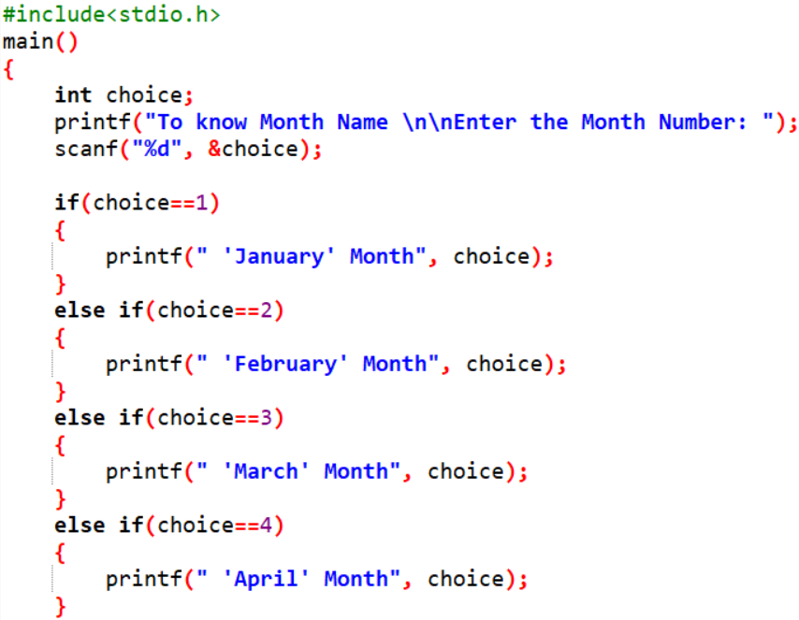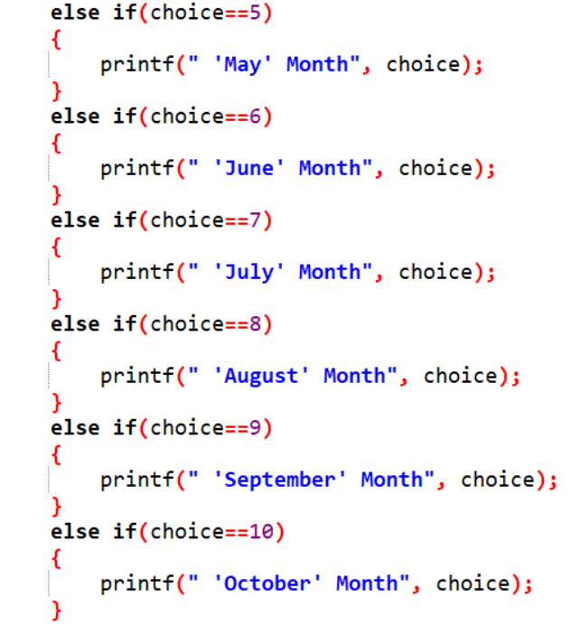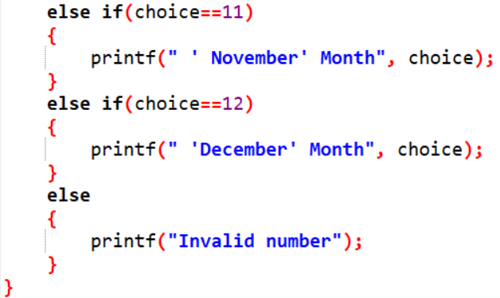

35.Accept the input month number and print number of days in that month.

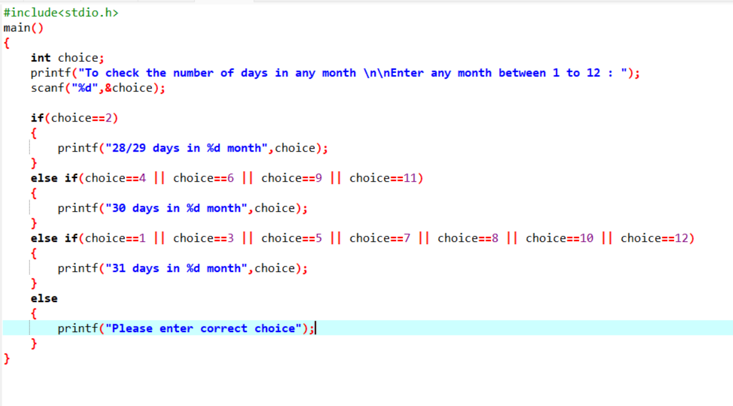

36.Write a C program to input electricity unit charges and calculate total electricity bill according to the given condition: For first 50 units Rs. 0.50/unit For next 100 units Rs. 0.75/unit For next 100 units Rs. 1.20/unit For unit above 250 Rs. 1.50/unit An additional surcharge of 20% is added to the bill

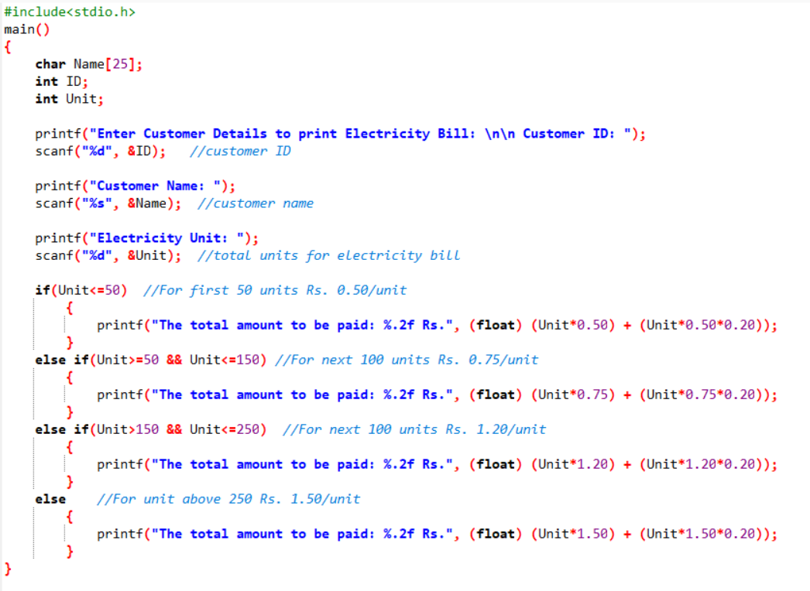

37. WAP to show i. Monday to Sunday using switch case ii. Vowel or Consonant using switch case

Topics Covered

LOOPING **STATEMENTS**

Conditional Statements

1. WAP to print 972 to 897 using for loop

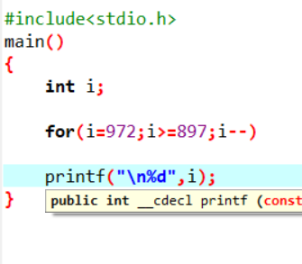

1. WAP to accept 5 numbers from user and display all numbers

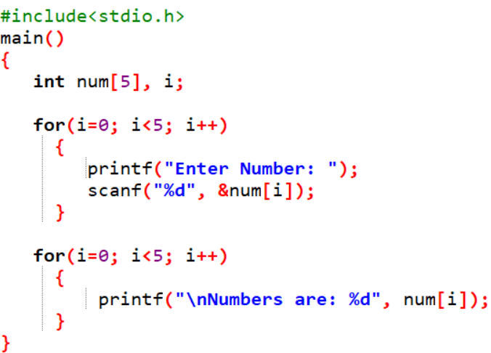

3. WAP to take 10 no. Input from user find out below values a. How many Even numbers are there

b. How many odd numbers are there

c. Sum of even numbers d. Sum of odd numbers

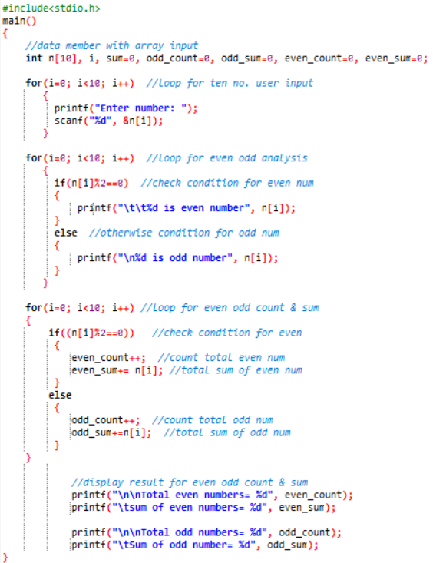

1. WAP to print table up to given numbers

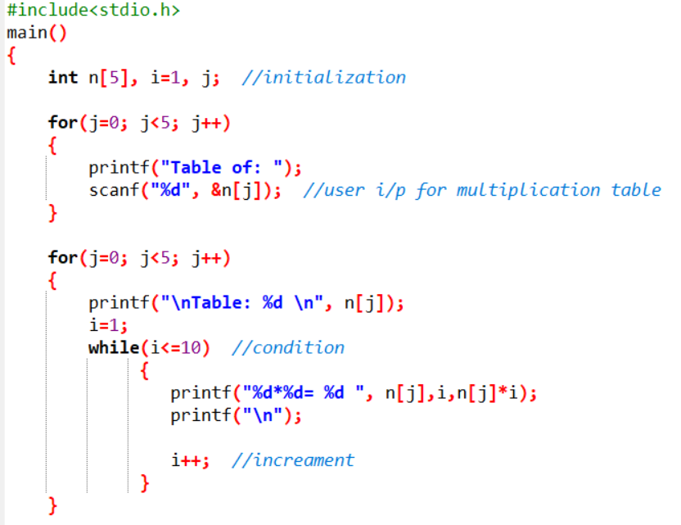

1. WAP to print factorial of given number

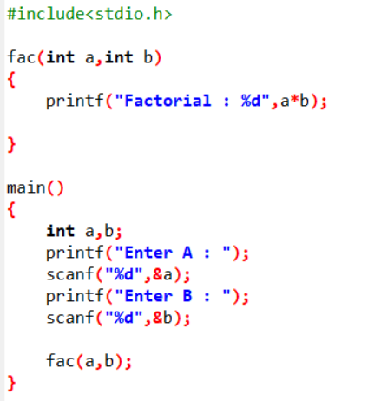

1. W0AP to print Fibonacci series up to given numbers

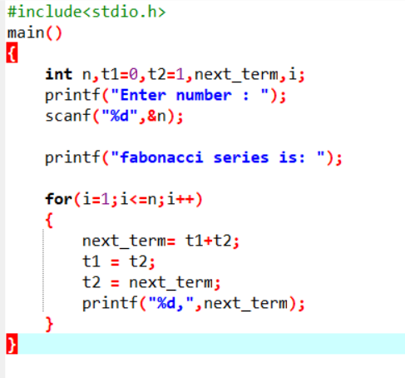

7. WAP to print number in reverse order e.g.: number = 64728 ---> reverse = 82746

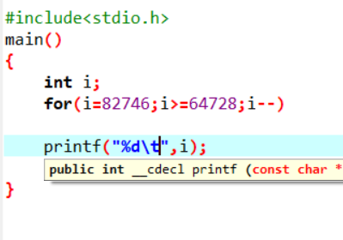

8.Write a program to find out the max from given number (E.g., No: -1562 Max number is 6)

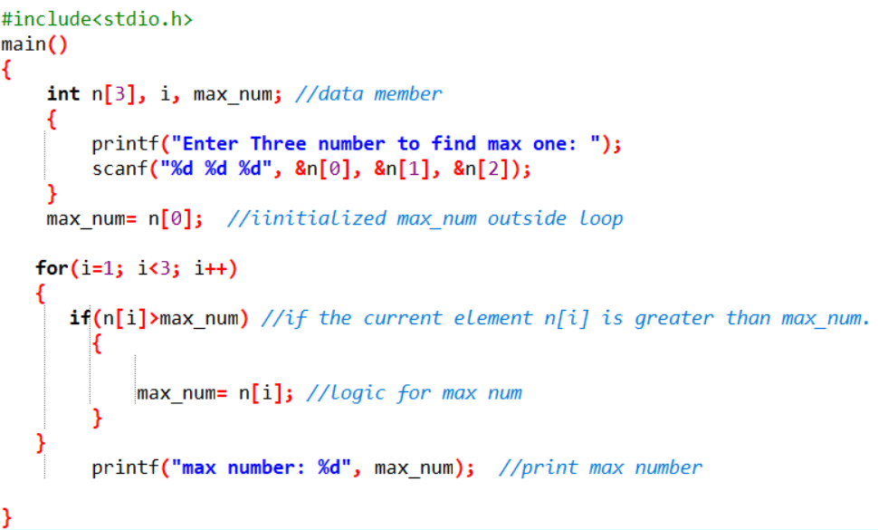

9.Write a program make a summation of given number (E.g., 1523 Ans: -11)

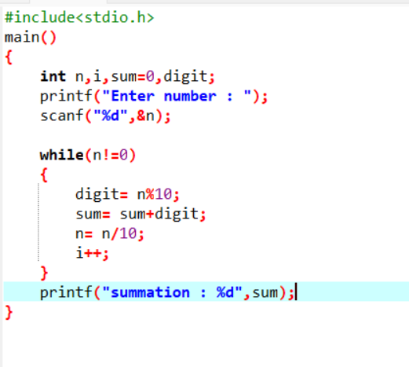

10.Write a program you have to make a summation of first and last Digit. (E.g., 1234 Ans: -5)

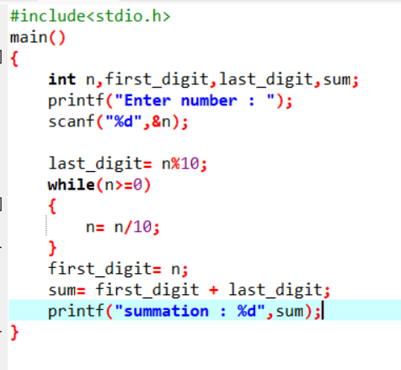

11.Accept 5 names from user at run time.

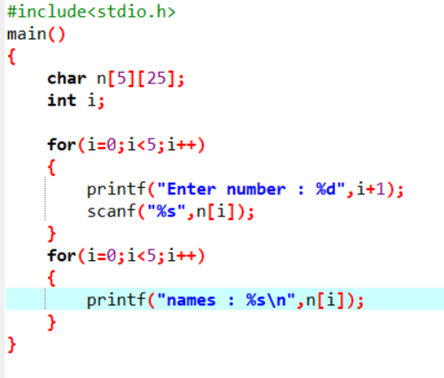

12.Program of Armstrong Number in C Using For Loop & While Loop

13.calculate the Factorial of a Given Number using while

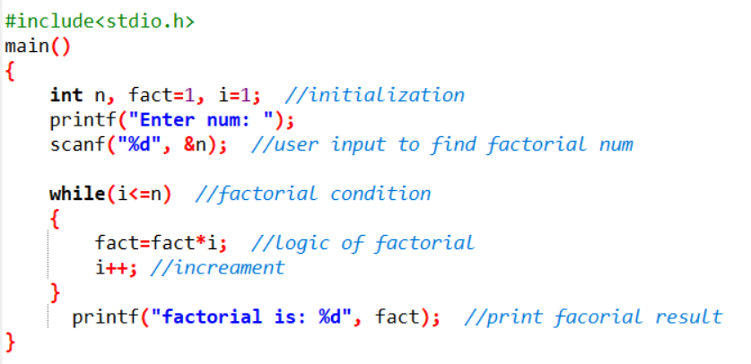

14.Accept 5 numbers from user and find those numbers factorials

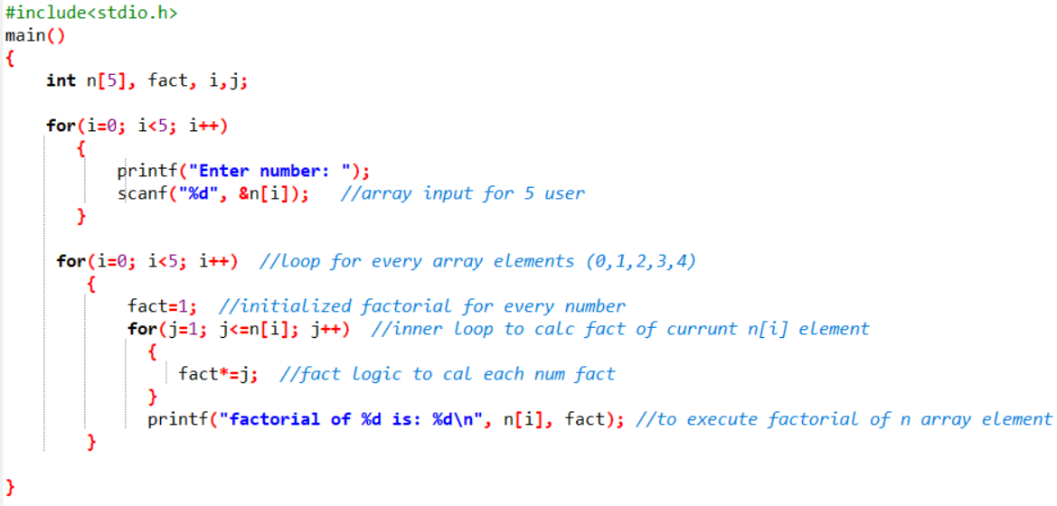

15.Calculate sum of 10 numbers using of while loop

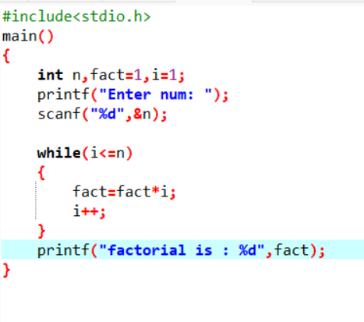

16.Calculate the Sum of Natural Numbers Using the While Loop

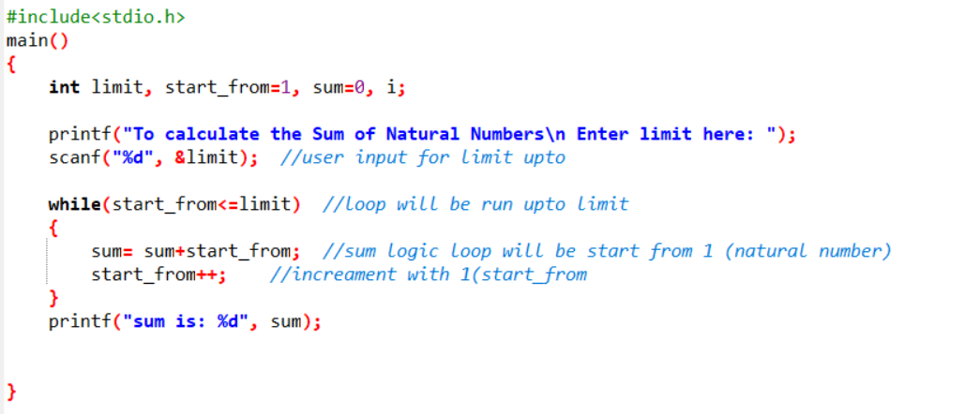

17.Calculate 5 numbers from user and calculate number of even and odd using of while loop 18.Write a C Program t

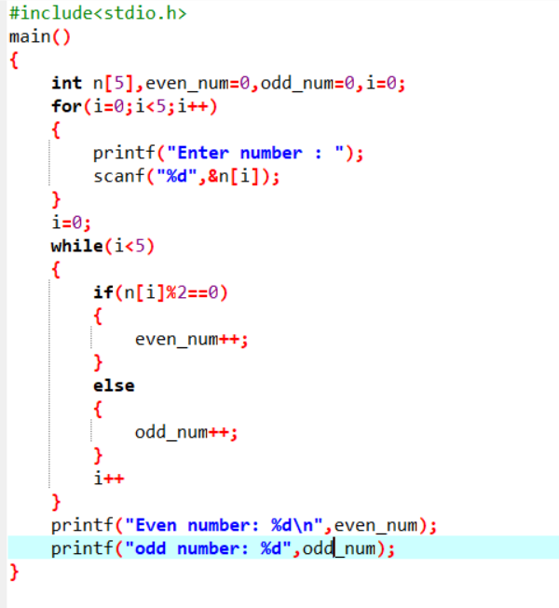

18.Write a C Program to Print the Multiplication Table of N

i. E.g. 5 * 1 = 5

ii. 5 * 2 = 10

1. .

2. . iii. 5 * 10 = 5

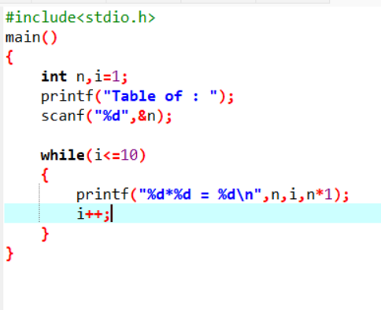

19. Patterns:

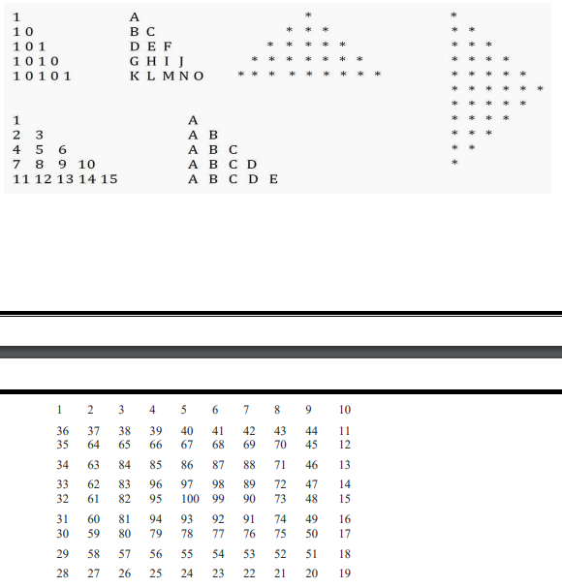

92 91 74 49 16 30 59 80 79 78 77 76 75 50 17 29 58 57 56 55 54 53 52 51 18 28 27 26 25 24 23 22 21 20 19

20. WAP program to print below output using for loop 01 02 03 04 05 06 07 08 09 10 11 12 13 14 15 16 17 18 19 20 .............. .............. 41 42 43 44 45 46 47 48 49 50

22. Accept 3 numbers from user using while loop and check each numbers palindrome

23. C Program to Reverse a Number Using FOR Loop Series Program: 24. 1 + 2 + 3 + 4 + 5 + ... + n 25. (1*1) + (2*2) + (3*3) + (4*4) + (5*5) + ... + (n*n) 26. (1)+ (1+2) + (1+2+3) + (1+2+3+4) + ... + (1+2+3+4+...+n) 27. 1/2 - 2/3 + 3/4 - 4/5 + 5/6 ..........n 28. 1 2 3 6 9 18 27 54...

Topics Covered

# Function :

# Array :

1. Write a program to find out the max number from given array using function

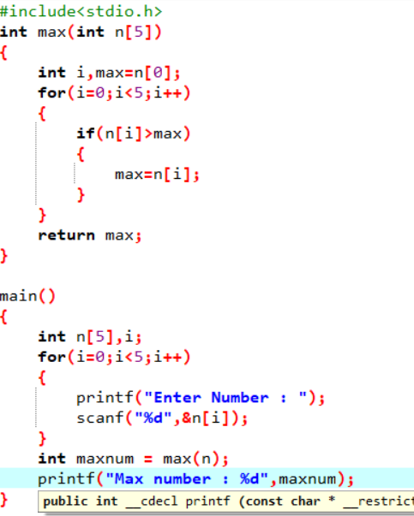

1. WAP of Addition, Subtraction, Multiplication and Division using Switch case.(Must Be Menu Driven)

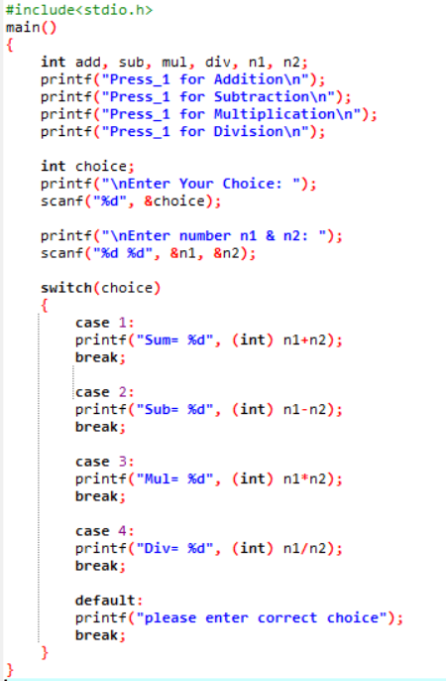

1. WAP to find reverse of string using recursion
2. WAP to find factorial using recursion

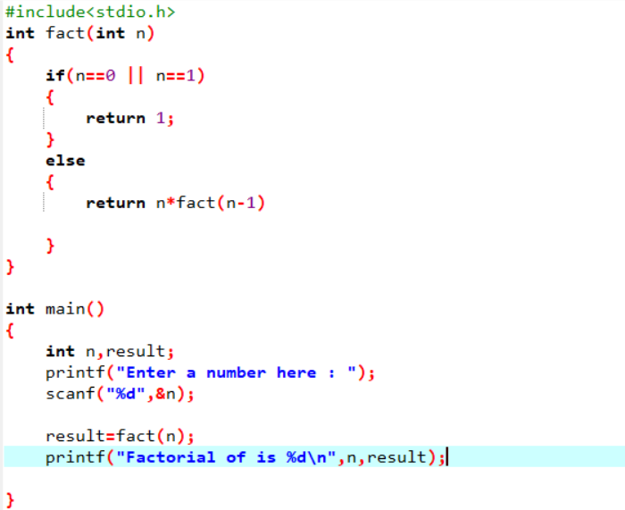

1. WAP to take two Array input from user and sort them in ascending or descending order as per user’s choice

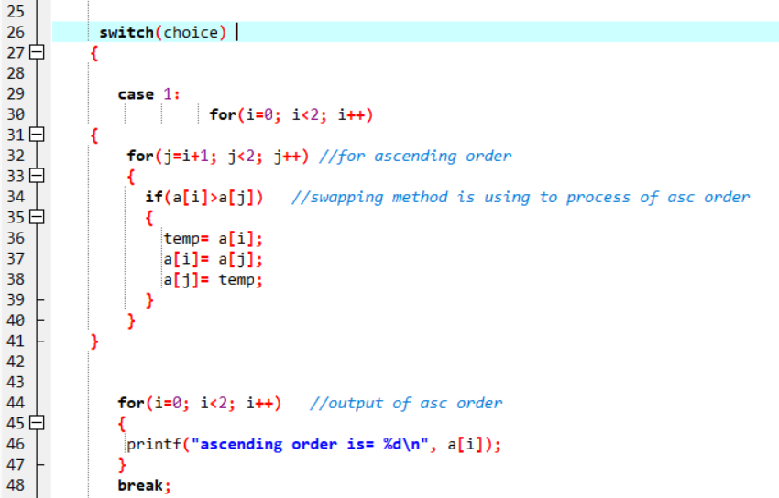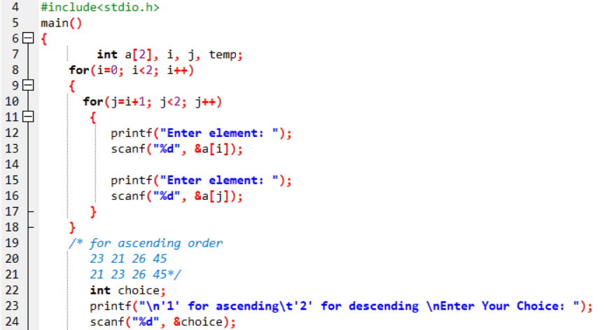

6. WAP to make addition, Subtraction and multiplication of two matrix using 2-D Array

7. WAP Find out length of string without using inbuilt function

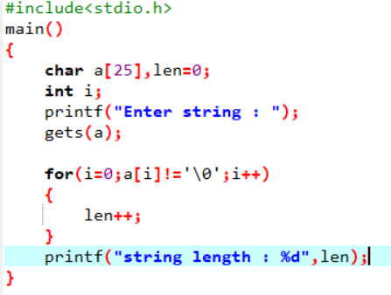

8. WAP to reverse a string and check that the string is palindrome or not Write a program of structure employee that provides the following

a. information -print and display empno, empname, address andage

b. Write a program of structure for five employee that provides the following information -print and display empno, empname, address andage

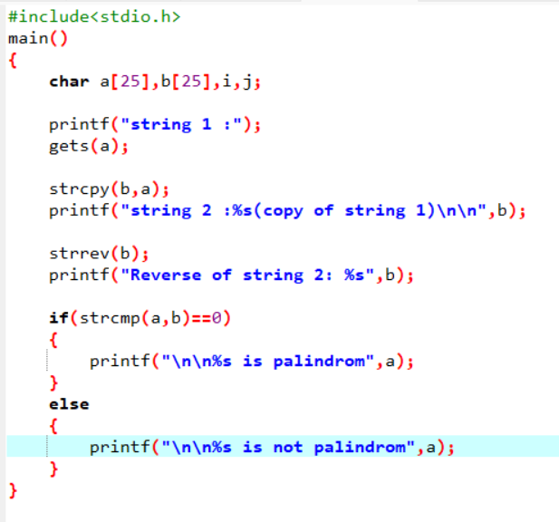

9.WAP to show difference between Structure and Union.

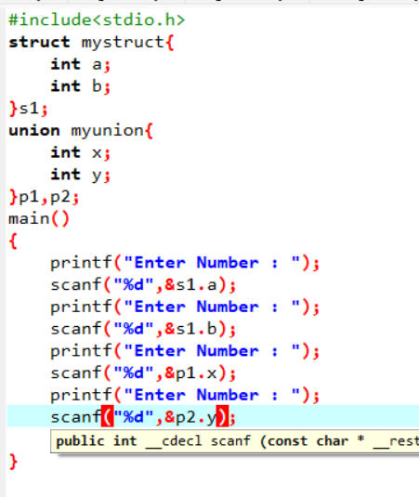

10.WAP to perform Palindrome number using for loop and function

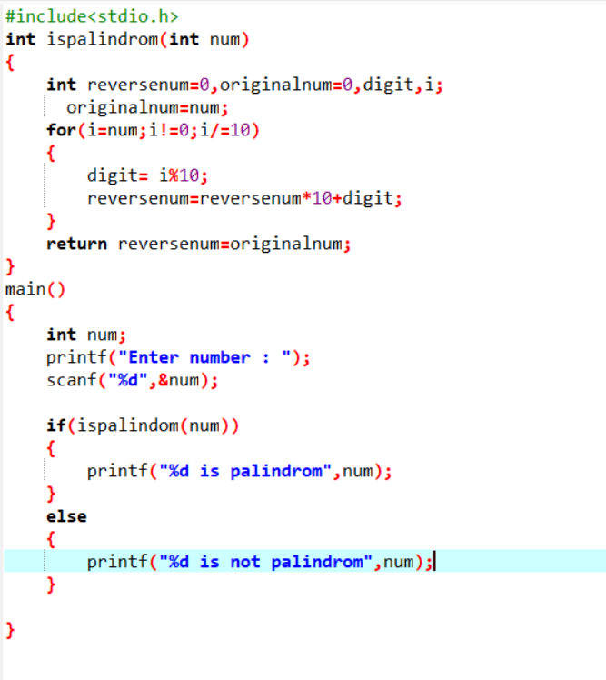

11.WAP to accept 5 numbers from user and display in reverse order using for loop and array

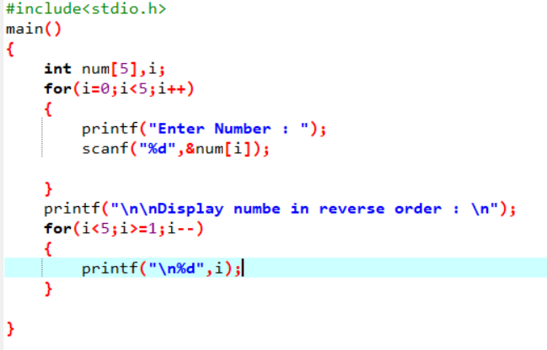

12.WAP to accept 5 students name and store it in array

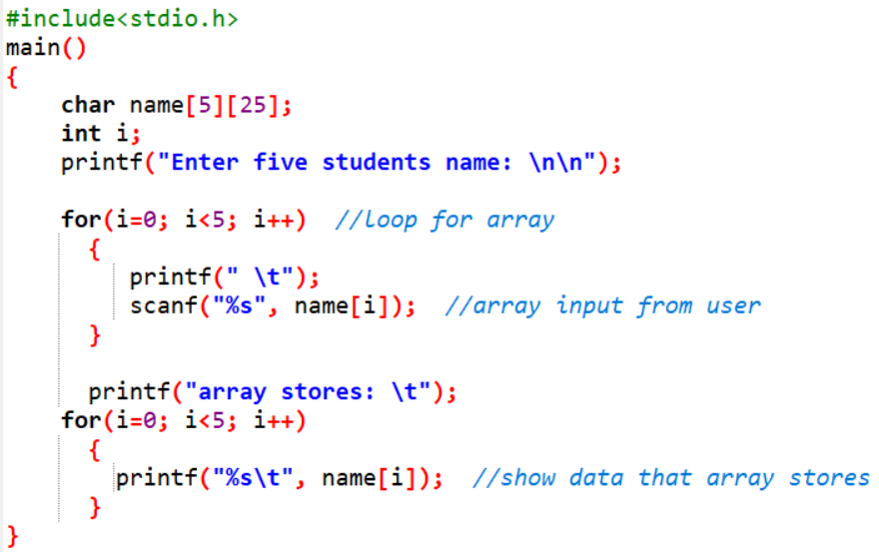

13.WAP to accept 5 numbers from user and check entered number is even or odd using of array

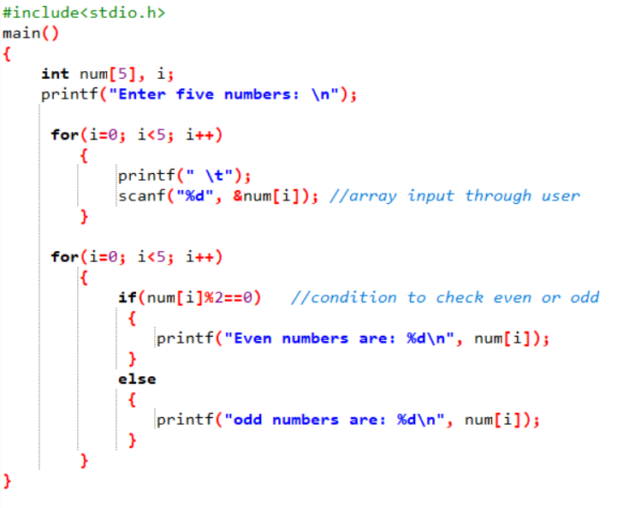

14.Perform 2D matrix array

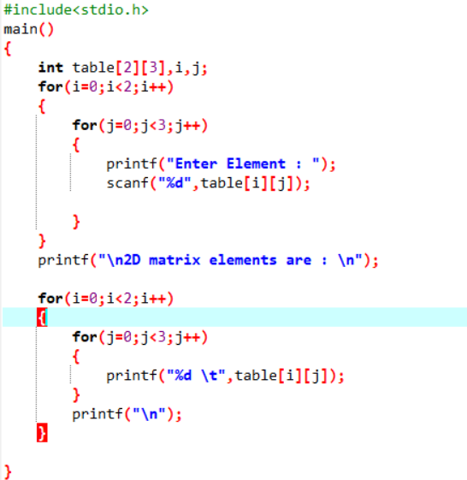

15.Store 5 numbers in array and sort it in ascending order

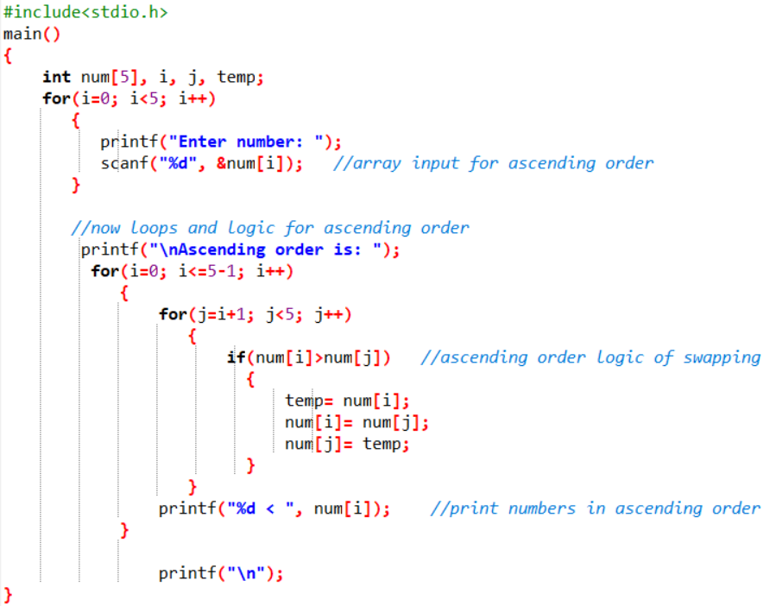

16.Accept 5 numbers from user and perform sum of array

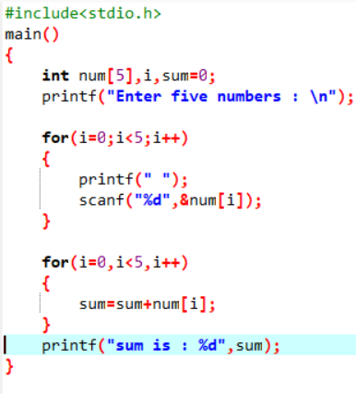

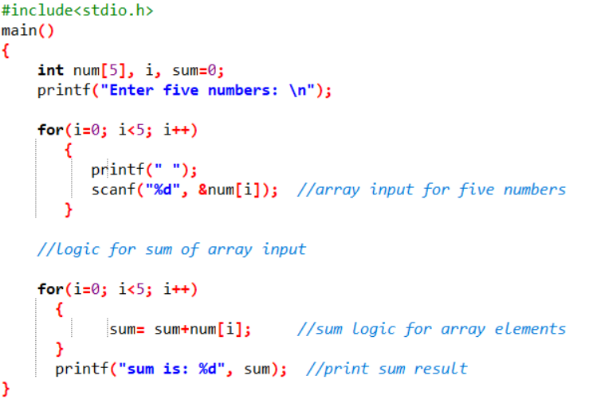

17.WAP to show difference between Structure and Union.

Topics Covered

String :

1. Write a program in C to find the length of a string without using library functions.

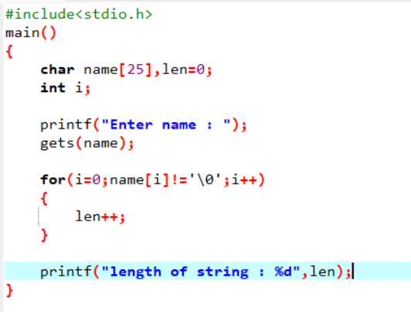

1. Write a program in C to separate individual characters from a string.

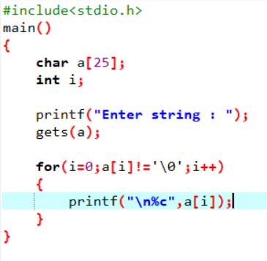

1. Write a program in C to print individual characters of a string in reverse order

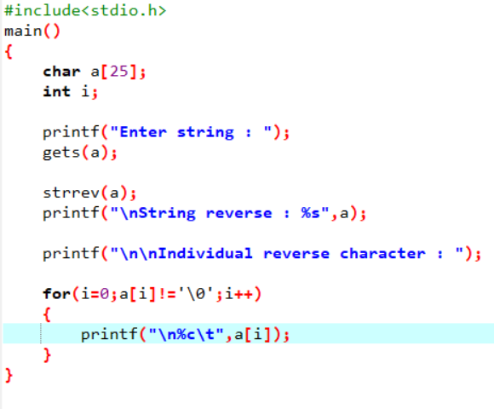

1. Write a program in C to count the total number of words in a string.

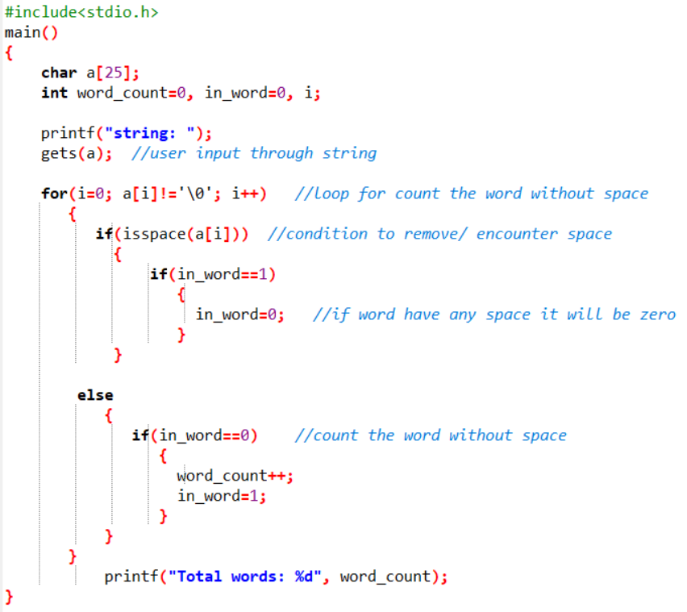

1. Write a program in C to compare two strings without using string library functions.
2. Write a program in C to count the total number of alphabets, digits and special characters in a string.
3. Write a program in C to copy one string to another string

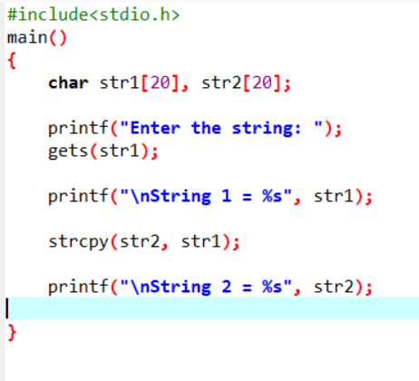

1. Write a program in C to count the total number of vowels or consonants in a string.

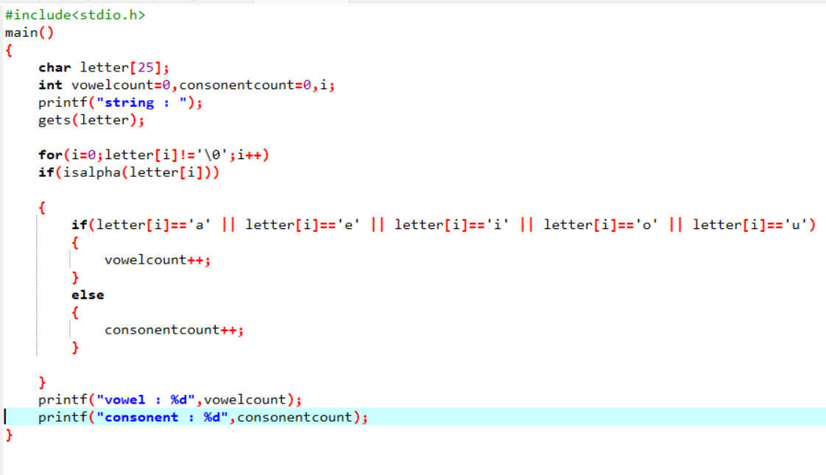

1. Write a program in C to find the maximum number of characters in a string.

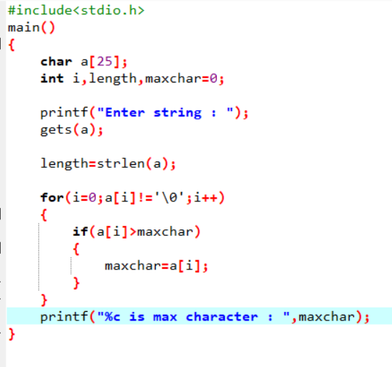

10.Write a program in C to extract a substring from a given string

11.Write a program in C to read a sentence and replace lowercase characters with uppercase and vice versa. 12.Write a program in C to find the number of times a given word 'is' appears in the given string.

13.Write a program in C to remove characters from a string except alphabets.

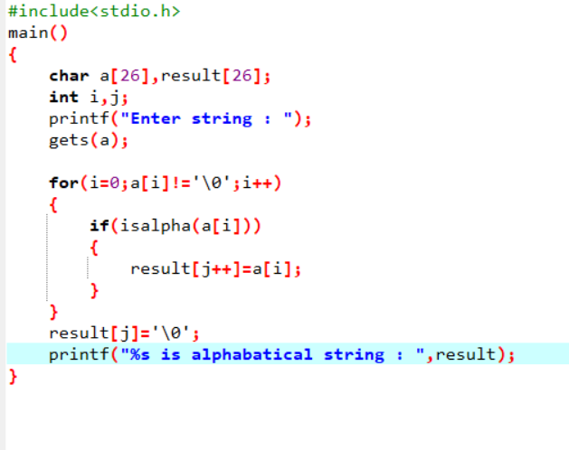

14.Write a program in C to combine two strings manually

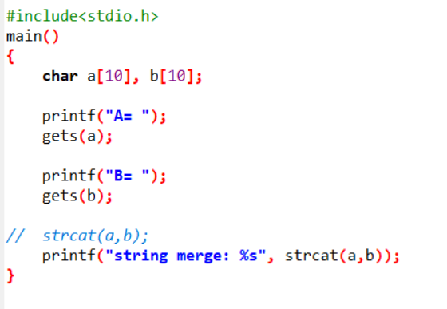

15.Write a program in C to find the largest and smallest words in a string